**DRAFT1 Lab 03 Relativistic Velocity Addition**

This is a lab under development by the Spacetime Java team in November 2024 to help explain the concept of relativistic velocity addition.

In addition to writing new course material, we are exploring ways that new web software and an interactive “notebook” style interface could increase the learning rate of new software developers and, eventually, physics students.

## Review on November 22, 2024

JB> Now 3 reference frames, not just 2.

JB> Specific concepts from Lab 1 + Lab 2 that would be helpful here?

How the clocks work in the reference frames and are synchronized.

JB> Valuable for this lab: Find the velocity of something using d = r * t to look at the clock readings and the measurement marks. Distances and times are different in diff ref frames. A good reminder of what velocity is.

Example: Bullet velocity relative to ground. Bullet relative to bus,

Step by step find each of the velocities.

Neat if they could discover the correct relationship, not an obvious formula.

Not providing the answers, sequence of steps. Repetition, doing something three times. (in each ref frame)

“What do you think you’re going to get?” Then check and see the discrepancy.

1. Find velocity of bus relative to found,
2. Find velocity of bullet relative to bus.
3. Predict bullet relative to ground.
4. Then we need a different model.

JB Has notes from a previous iteration. Jogged memory.

TB> Re-doing the calculations in each reference frame.

Visually Organize – a table of steps to do for each reference frame. An event table. Finding position + time coordinates in each reference frame.

Find starting position of bullet, ending position of bullet.

Creating an event table.

Ask them to look at clocks and tick mark distance measurements (Done in previous 1+2).

* Justin> Next Step – write instructions: 1. Open animation, 2. Notice what’s on the screen. 3. Find the different events, write down position and time coordinates. 4. Do it for 3 reference frames. 5. Use the classic velocity calculation, do the math to determine the velocity of the bullet in each reference frame.

Use the java software to make obsservations, write them down, and make calculations based on those observations.

* Taylor> Next Step: More Illustrations: 1. Connect the mental model to a higher fidelity that overlays what you see on Spacetime Java.

Free Illustration: Inkscape.

* Justin> Make a frame for the Lab Document
* Dr. Bennett> Find the notes from Previous Lab assigments.

## Concepts that Students Should Learn from this Lab

(Taylor) **Velocity Acceleration** - Learn the formulas for how changes in velocity (also known as Acceleration) or velocity additions (objects launched, bullets, light flashes, etc), in one reference frame are observed from another reference frame.

(Taylor) **Special Relativity applies to Classical Physics** – Understand mathematically why the classical mechanics velocity addition ( Distance = Rate x Time ) works for very low Beta velocities.

(Taylor) **Lorentz Refresher** - Solid understanding of length contraction and the supporting equations that use Beta and Gamma, all powered by the Lorentz transformation.

(Taylor) **Next Lab** - Be Ready for Lab 04 – Accelerating Rod.

(Brandon) **Units of Measure in Lorentz Transformations** - Have the students understand how we factor the distance and time units in the Lorentz Transformation equations 1.22 and 1.23

(Modern Physics 1.22)

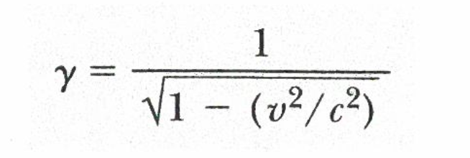

(Modern Physics 1.23)

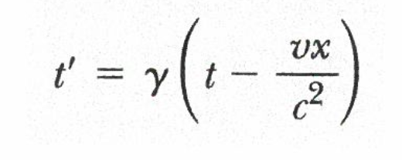

(Brandon) - **Gamma and Beta** related to each other

The greater the Beta, the greater the gamma, therefore the greater the time dilation and the greater the length contraction

(Taylor) – **Length Contraction is Longitudinal** in the Direction of the Velocity - The length contraction is consistent for all points on the bus. The proportion / ratio of the observer from the back of the bus will be the same no matter the length contraction.

(Dr. Bennett) – **Simultaneous and Simulocal Events** - Two events that are simultaneous (same time) and simu-local (same point in space) must occur at the same time and same location in all reference frames. This is because the Spacetime interval is zero. A zero interval in any reference frame must be a zero interval in all reference frames.

## Prerequisites to this Lab

1. If you need a refresher on any of these concepts, complete Lab 01 and Lab 02.
2. Understanding what multiple Reference Frames are and to expect that observations from different reference frames will not always agree.
   1. In Lab 3, we have three reference frames, a Space Bus and Earth and Bullet.
   2. Understanding the notation of the “primed” variables that refer to observations and measurements from the different reference frames.
3. **NOT NEEDED**: Understanding of Simultaneity and Cause and Effect, and how events can be “Time-like” and “Space-like”. ( Not necessarily needed ).
4. Understanding ‘Beta’, which is velocity expressed in terms of a 0 to 1 factor of the speed of light, c and the associated units of measure.
5. **NOT NEEDED**: Understanding that the velocity and distance can be interchanged using the speed of light to standardize the units and make calculations easier. c = 299,792,458 meters / second. Distance = Rate * Time. 1 light second = 299,792,458 meters. But you often never need to use this rate; ‘c’ just cancels out on each side of the equation.
6. **NOT NEEDED**: Spacetime Diagrams. ? Unless we add one to Lab 03
7. An understanding of Lorentz transformations, spacetime invariant, Gamma, and the supporting formulas. Modern Physics 1.6 does a good job of a differential equation-based proof that results in Gamma, formula 1.26:

1. **For Now Until the Web Version is Available**: The Spacetime Java (or Web) Application running the different scenarios and understanding how to step time forward, backwards, jump to different reference frames, and look up values from the Event and The Object Tables.

### Why doesn’t the classic relativity work for adding velocity at high betas?

3/4 Beta + 3/4 Beta != 6/4 Beta = 1.5 Beta – because nothing can have a velocity greater than 1 Beta.

So something must be wrong!

If you do it the way you’ve always done it, it won’t work.

## Ideas for Diagrams

### Modern Physics, Page 19,Length Contraction

### Spacetime Java scenarios/velocity addition.sce

Highway

t = 0.000

t = 4.584

Spacetime Diagram

t = 4.000

t = 4.584

### The “Seat 3A” Description , Taylor’s Sketch in Omnigraffle – Supports 3-11 d.

Space Bus Reference Frame:

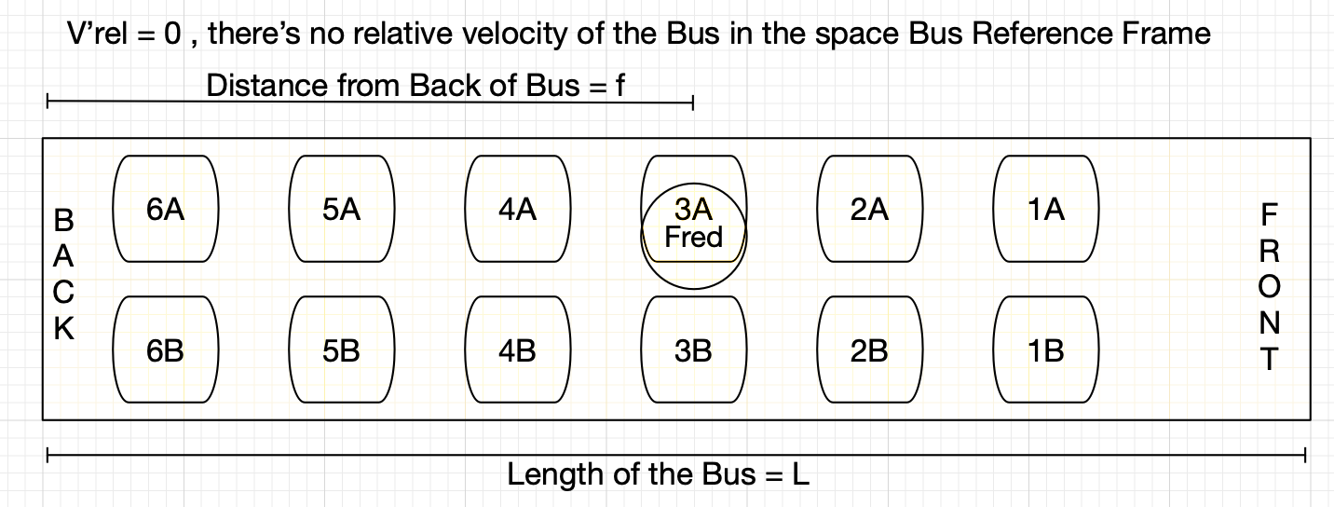

Earth Reference Frame

